

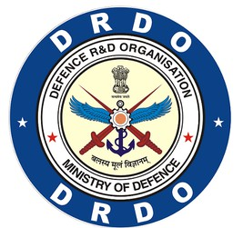

###### An Industry Internship Report on

**Classification of Ships using ISAR Images**

*Submitted in partial fulfilment of requirements for award of the degree of*

**Bachelor of Engineering**

**in**

**Electronics & Communication Engineering**

for the **Academic Year: 2025-26**

*Department of D-ASR, RADAR -V*

*Under the Guidance of*

**Dr. Dyana A, Scientist ‘E’**

*Submitted by*

**Mr. Manaswin Manoj (ENG22AM0180)**

**Department of Computer Science and Engineering**

**(Artificial Intelligance and Mahine Learning)**

**Dayananda Sagar University**

**Bengaluru-562112**

**2025-2026**

#### 

Certificate

This is to certify that the internship work entitled **“Classification of Ships using ISAR Images”** has been successfully carried out by **Mr.** **Manaswin Manoj (ENG22AM0180)**, a bonafide student of VI Semester Electronics & Communication Engineering, **Dayananda Sagar University**, in partial fulfillment of the requirements for the award of the degree of **Bachelor of Engineering in Department of Computer Science and Engineering ( Artificial Intelligance and Mahine Learning )** during the academic year **2025–2026**.

|  |  |
| --- | --- |
| **Dr. Jayavrinda V Vadakkeparambil**  Professor & HOD,  Dept. CSE(AIML)  Dayananda Sagar University | **Dr. Udaya Kumar Reddy KR**  Dean,  School of Engineering  Dayananda Sagar University |

**Acknowledgement**

The successful completion of our internship marks a significant milestone in our academic journey. We take this opportunity to express our heartfelt gratitude to all those who supported and guided us throughout this enriching experience. Whatever we have achieved is the result of their encouragement, support, and timely guidance, for which we remain deeply thankful.

We extend our special thanks to our beloved of **Dr. Udaya Kumar Reddy KR**

Dean, School of Engineering, for providing the infrastructure, resources, and motivation that enabled us to successfully complete our internship.

We would like to express our deep appreciation to **Dr. Jayavrinda V Vadakkeparambil**, Head of the Department, Computer Science and Engineering(Artificial Intelligence and Machine Learning), for her constant encouragement and for facilitating internship opportunities that bridge the gap between academia and industry.

We are immensely thankful to Dr. Dyana A, Scientist ‘E’ for her invaluable mentorship, timely feedback, and continuous support during our internship period.

We also acknowledge with gratitude the support of our parents for their unwavering encouragement and belief in us.

Mr. Manaswin Manoj (ENG22AM0180)

Place: Bengaluru

Date: 22/05/2025

# Executive Summary

During my internship at the **Electronics and Radar Development Establishment (LRDE), DRDO**, I was involved in a project titled *“Classification of Ships Using ISAR Images”*. The primary objective was to develop and evaluate deep learning models capable of classifying ship types using Inverse Synthetic Aperture Radar (ISAR) images.

My role focused on designing and implementing three different image classification models: **Convolutional Neural Network (CNN)**, **Deep CNN (DCNN)**, and **Vision Transformer (ViT)**. I built an end-to-end web- based pipeline using **Flask**, which enabled users to upload datasets, train models, and perform real-time testing with new images.

Key tasks included:

* Preprocessing and augmenting grayscale ISAR images.
* Developing CNN, DCNN, and ViT architectures tailored for radar-based image inputs.
* Training and validating models with varying parameters and hyperparameters.
* Evaluating models using metrics like accuracy, confusion matrix, and classification reports.
* Building an interactive web application to streamline model training and testing workflows.

**Contents**

Acknowledgement i

Executive Summary ii

List of Tables iv

List of Figures v

1. Introduction 1
   1. Objectives of the Internship . . . . . . . . . . . . . . . . . . . . . . . . . . . . . . . . . . . 1
   2. Overview of the Organization . . . . . . . . . . . . . . . . . . . . . . . . . . . . . . . . . . 1
   3. Internship Role/Position . . . . . . . . . . . . . . . . . . . . . . . . . . . . . . . . . . . . . 2
2. Internship Activities and Tasks 3
   1. Tasks and Responsibilities . . . . . . . . . . . . . . . . . . . . . . . . . . . . . . . . . . . . 3
   2. Tools and Technologies Used . . . . . . . . . . . . . . . . . . . . . . . . . . . . . . . . . . 4
   3. Projects Involved In . . . . . . . . . . . . . . . . . . . . . . . . . . . . . . . . . . . . . . . 4
3. Learning Outcomes 8
   1. Skills Gained . . . . . . . . . . . . . . . . . . . . . . . . . . . . . . . . . . . . . . . . . . . 8
   2. Challenges Faced . . . . . . . . . . . . . . . . . . . . . . . . . . . . . . . . . . . . . . . . . 8
   3. Results and Discussions . . . . . . . . . . . . . . . . . . . . . . . . . . . . . . . . . . . . . 9
   4. Takeaways . . . . . . . . . . . . . . . . . . . . . . . . . . . . . . . . . . . . . . . . . . . . 9
4. Reflection and Analysis 13
5. Conclusion 15

# List of Tables

* 1. Model Performance Comparison . . . . . . . . . . . . . . . . . . . . . . . . . . . . . . . . . 9

# List of Figures

* 1. Architecture Diagram of CNN Model . . . . . . . . . . . . . . . . . . . . . . . . . . . . . . 5
  2. Architecture Diagram of ViTs Model . . . . . . . . . . . . . . . . . . . . . . . . . . . . . . 6
  3. Selection of required model and the ISAR Dataset 10
  4. Confusion Matrix and Classification Report for CNN 10
  5. Confusion Matrix and Classification Report for DCNN 11
  6. Confusion Matrix and Classification Report for ViTs 11
  7. Prediction of the Class of the Ship based on the Selected Model 12

**Chapter 1 Introduction**

### Objectives of the Internship

The internship at the **Electronics and Radar Development Establishment (LRDE)**, a premier laboratory un- der the **Defence Research and Development Organisation (DRDO)**, was aimed at bridging the gap between academic knowledge and practical application. The academic objective was to explore the implementation of deep learning techniques in radar-based image classification, while the personal goal was to gain hands-on experience in working with real-world defense data, develop web applications, and enhance skills in computer vision and model evaluation.

Specifically, the internship aimed to:

* + - Understand the challenges and applications of Inverse Synthetic Aperture Radar (ISAR) imaging.
    - Develop and compare various deep learning models for classifying ships using ISAR images.
    - Integrate model development with an interactive user-friendly interface for practical testing.

### Overview of the Organization

The **Electronics and Radar Development Establishment (LRDE)** is one of the key laboratories functioning under the umbrella of **DRDO**, Ministry of Defence, Government of India. Established with the mission to develop radar and related technologies for the Indian Armed Forces, LRDE has contributed significantly to the design and development of state-of-the-art radar systems.

* + - **Industry:** Defense Research and Development

Internship Title 2024-25

* + - **Founded:** 1958
    - **Location:** Bengaluru, Karnataka
    - **Mission:** To design and develop modern electronic systems, especially radar systems, for India’s defense and surveillance needs.

LRDE is known for its involvement in prestigious projects like 3D Tactical Control Radar (TCR), Battlefield Surveillance Radar (BFSR), and Weapon Locating Radar (WLR), making it an integral part of India’s self- reliant defense ecosystem.

### Internship Role*/*Position

During the internship, I served as a **Student Trainee** under the guidance of domain experts in the radar image processing division. My role was centered on the project titled *“Classification of Ships Using ISAR Images”*, where I was responsible for designing, training, and evaluating multiple deep learning models to classify ship types from radar images.

The tasks also involved:

* + - Preprocessing radar image datasets and applying augmentation techniques.
    - Developing CNN, DCNN, and Vision Transformer (ViT) models.
    - Integrating the models into a web application using Flask.

This role allowed me to contribute directly to a defense-focused research problem, gain exposure to real ISAR datasets.

**Chapter 2**

**Internship Activities and Tasks**

### Tasks and Responsibilities

During my internship at the **Electronics and Radar Development Establishment (LRDE), DRDO**, I was assigned a series of responsibilities, categorized as follows:

##### Research and Understanding

* Studied the fundamentals of radar imaging, specifically Inverse Synthetic Aperture Radar (ISAR).
* Reviewed existing literature on ship classification using machine learning and deep learning approaches.
* Analyzed challenges involved in working with grayscale radar image datasets.

##### Technical Work

* Preprocessed ISAR images by resizing, normalization, and data augmentation.
* Designed and trained three deep learning models: CNN, DCNN, and Vision Transformer (ViT).
* Fine-tuned hyperparameters such as learning rate, batch size, and number of epochs to improve accuracy.
* Evaluated models using accuracy, confusion matrix, and classification reports.

##### Web Application Development

* Developed a Flask-based web interface to allow real-time testing and training.

Internship Title 2024-25

* Integrated file upload features, model training triggers, and output display (prediction results).
* Ensured a smooth end-to-end pipeline from image upload to prediction display.

### Tools and Technologies Used

* + - **Programming Languages:** Python
    - **Frameworks***/***Libraries:** TensorFlow, Keras, NumPy, Matplotlib
    - **Web Technologies:** Flask, HTML/CSS (for frontend styling)
    - **Tools:** Visual Studio Code
    - **Image Data:** Grayscale ISAR (Inverse Synthetic Aperture Radar) images

### Projects Involved In

##### Project Title: Classification of Ships Using ISAR Images

* + - **Objective:** To build and evaluate deep learning models capable of identifying ship classes from radar images.
    - **Scope:** Design and implementation of CNN, DCNN, and ViT models. Creation of a user-friendly web interface.
    - Model Architectures:

The first model developed was a **Convolutional Neural Network (CNN)**, a widely-used architecture for image classification tasks. The CNN consisted of multiple convolutional layers with ReLU activation functions, followed by MaxPooling layers to reduce spatial dimensions and extract key features. These were followed by fully connected dense layers ending in a softmax classifier. The CNN was chosen as a baseline because of its efficiency in identifying spatial patterns and textures within radar images. Its relatively low computational complexity made it suitable for initial experiments with ISAR data.

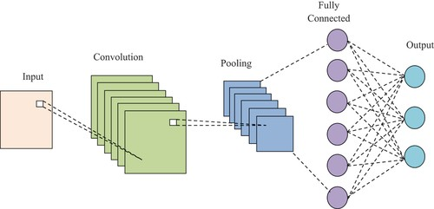Internship Title 2024-25

Figure 2.1: Architecture Diagram of CNN Model

To improve performance and learn more complex features, a **Deep Convolutional Neural Network (DCNN)** was implemented. This model expanded on the basic CNN by increasing the number of convolutional layers and incorporating Batch Normalization and Dropout layers. These additions helped to stabilize the learning process and prevent overfitting. The DCNN demonstrated better generalization capabilities and was particularly effective in capturing finer details from grayscale radar images, which was crucial for distinguishing between visually similar ship classes.

The third and most advanced model employed was the **Vision Transformer (ViT)**. Unlike CNNs, which rely on local receptive fields, ViTs process images as a sequence of patches and apply self-attention mechanisms to capture global dependencies. The model architecture involved splitting each ISAR image into fixed-size patches, embedding them linearly, and adding positional encodings to retain spatial information. These embeddings were then passed through multiple transformer encoder blocks. The ViT was chosen due to its state-of-the-art performance on image classification benchmarks and its ability to model long-range relationships, which proved beneficial for complex radar data where relevant features might be spatially distant.

Internship Title 2024-25

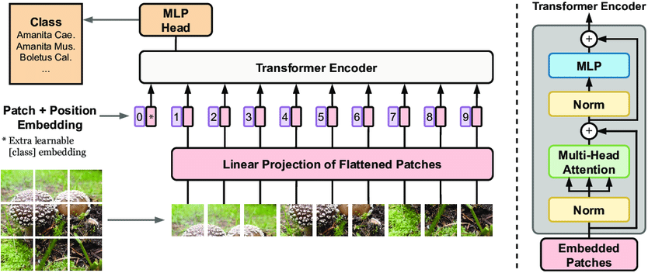

Figure 2.2: Architecture Diagram of ViTs Model

Overall, the use of CNN provided a strong foundation, DCNN enhanced feature representation through depth, and ViT leveraged attention-based mechanisms for global understanding. Each architecture contributed uniquely to the project’s objective of accurate ship classification using ISAR images.

**Methodology**

The project began with the collection and preparation of the ISAR image dataset. Raw grayscale radar images were first uploaded and organized into respective classes representing different ship types. These images were then preprocessed to standardize input dimensions by resizing and normalizing pixel values. To increase the robustness of the models and prevent overfitting, various image augmentation techniques such as horizontal and vertical flipping, rotation, and zooming were applied.

Following dataset preparation, the three deep learning models—CNN, DCNN, and Vision Transformer (ViT)—were developed using TensorFlow and Keras frameworks. Each model was carefully designed to suit the characteristics of ISAR images, with appropriate layers and hyperparameters configured through experimentation. Training was conducted over multiple epochs using a defined batch size, and early stopping criteria were implemented to avoid unnecessary computation once the models converged.

Model performance was rigorously evaluated using metrics such as accuracy, confusion matrices, and classification reports. These evaluations helped identify the strengths and weaknesses of each architecture in distinguishing between ship classes, guiding iterative refinements. Finally, to enable practical usability, the trained models were integrated into a Flask-based web application. This interface provided users with the ability to upload new ISAR images, trigger model inference, and view

Internship Title 2024-25

classification results in real time, thereby demonstrating an end-to-end system from data ingestion to actionable output.

**Chapter 3 Learning Outcomes**

### Skills Gained

During the course of the internship at **Electronics and Radar Development Establishment (LRDE), DRDO**, I acquired a broad range of both technical and soft skills. Technically, I strengthened my proficiency in Python programming and gained in-depth experience with deep learning libraries such as TensorFlow and Keras. I learned to design, train, and evaluate neural network models—including CNNs, DCNNs, and Vision Transformers—for radar-based image classification tasks.

In addition, I became proficient in preprocessing radar image data, applying augmentation techniques, and fine-tuning hyperparameters. I also learned how to develop an end-to-end web application using Flask to deploy deep learning models for real-time testing, which significantly improved my skills in full-stack development.

Soft skills gained include enhanced problem-solving capabilities, time management, and communication skills. Collaborating with mentors and presenting project updates helped me refine my ability to convey complex technical ideas clearly and effectively.

### Challenges Faced

One of the primary challenges was dealing with grayscale ISAR images that had low contrast and significant noise. These images differed from conventional RGB datasets, requiring customized preprocessing and augmentation strategies. I overcame this by experimenting with image enhancement techniques and carefully adjusting model architectures to extract meaningful features.

Another challenge was optimizing the training process for the Vision Transformer (ViT), which is inherently data-hungry. Due to the limited size of the dataset, I incorporated strong regularization and fine-

Internship Title 2024-25

tuned the patch size and number of attention heads to achieve better performance.

Integrating the trained models into a Flask web application also posed challenges, especially in handling asynchronous model training and real-time prediction without freezing the interface. These were addressed through the use of background threading and modularizing the codebase.

### Results and Discussions

* + - **CNN Model:** Achieved moderate classification accuracy with faster training time; best suited for simpler radar image datasets.
    - **DCNN Model:** Showed improved accuracy and robustness compared to CNN, especially in complex ship classes.
    - **ViT Model:** Delivered competitive performance with higher generalization but required careful tuning and longer training time.

The confusion matrix and classification report showed that the DCNN model provided a balanced trade-off between performance and resource consumption. Below are the summary metrics:

|  |  |
| --- | --- |
| **Model** | **Test Accuracy** |
| CNN | 90.20% |
| DCNN | 91.67% |
| ViT | 87.85% |

Table 3.1: Model Performance Comparison

### Takeaways

This internship provided me with invaluable exposure to the real-world application of artificial intelligence in defense. I learned how to adapt deep learning techniques to non-standard data formats like radar images. It deepened my understanding of neural network architectures and gave me confidence in building scalable AI pipelines.

Working in a research-driven environment also taught me how to approach problems methodically, validate solutions rigorously, and communicate results effectively. Overall, it was a transformative experience that solidified my interest in AI and computer vision as future career paths.

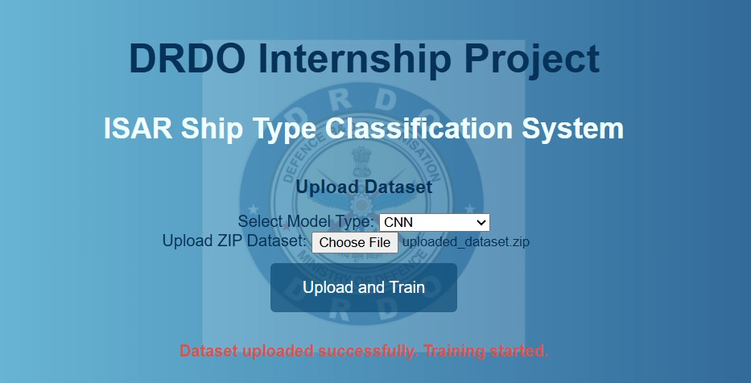Internship Title 2024-25

Figure 3.1: Selection of required model and the ISAR Dataset

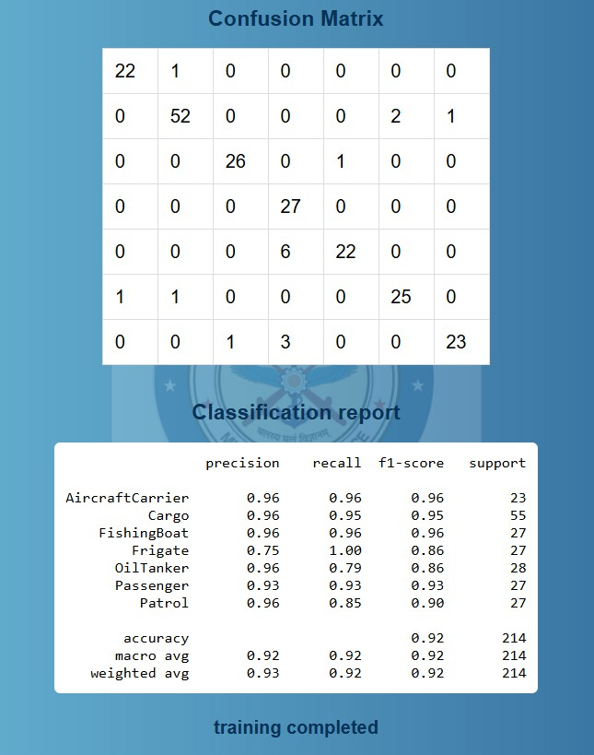

Figure 3.2: Confusion Matrix and Classification Report for CNN

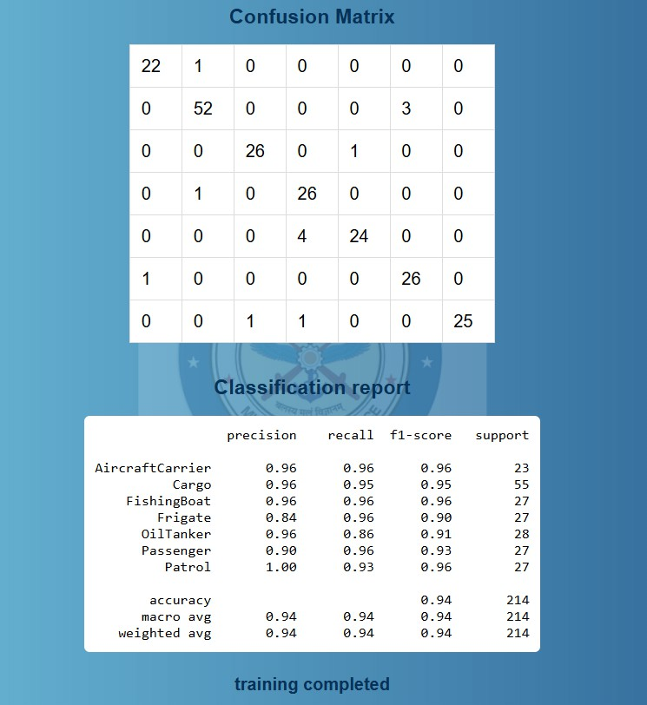Internship Title 2024-25

Figure 3.3: Confusion Matrix and Classification Report for DCNN

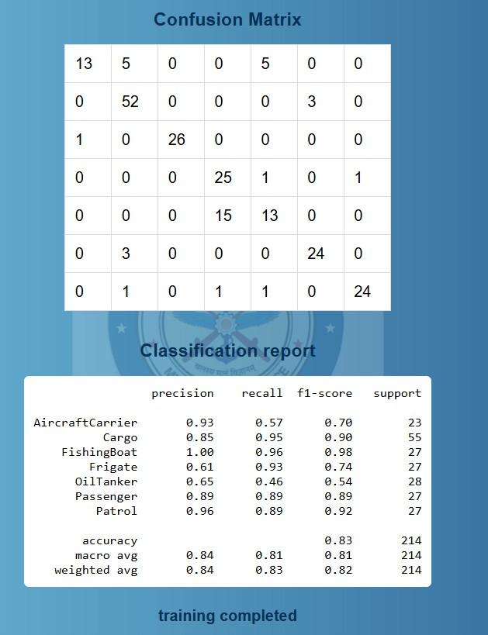

Figure 3.4: Confusion Matrix and Classification Report for ViTs

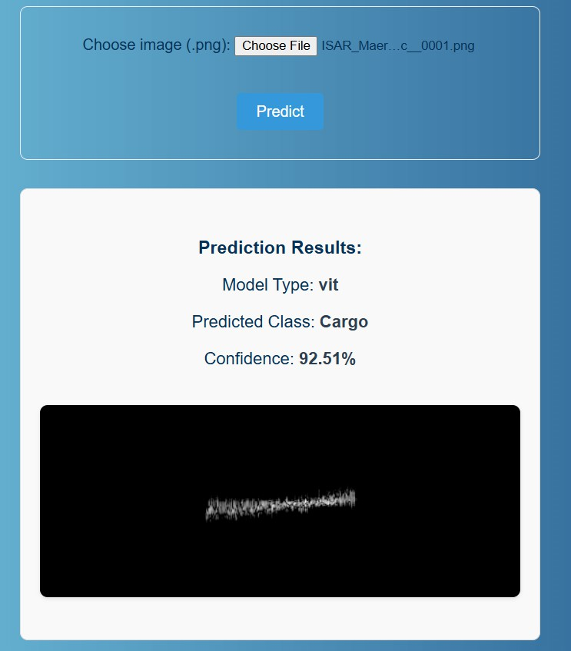Internship Title 2024-25

Figure 3.5: Prediction of the Class of the Ship based on the Selected Model

**Chapter 4**

**Reflection and Analysis**

**Application of Academic Knowledge**

During my internship at the Electronics and Radar Development Establishment (LRDE), DRDO, I was able to effectively apply various theoretical concepts learned in my academic coursework. The foundational knowledge of machine learning and deep learning, especially in neural networks, was crucial for understanding and designing the CNN, DCNN, and Vision Transformer models. Courses on signal processing and image analysis helped me grasp the unique characteristics of ISAR images and informed the preprocessing and augmentation techniques I applied. Additionally, my studies in software development enabled me to build the Flask web application, integrating model training and testing into a cohesive pipeline.

**Insights Gained**

This internship provided valuable insights into the defense research sector and the practical challenges faced when working with radar-based imaging data. I learned the importance of tailoring machine learning models to domain-specific data, such as handling the noise and resolution constraints inherent in ISAR images. The workplace culture emphasized meticulous research, rigorous evaluation, and iterative improvement, which sharpened my attention to detail and analytical skills. I also experienced the collaborative nature of research projects and the integration of multiple technologies to deliver functional solutions.

Internship Title 2024-25

**Areas for Improvement**

Through this internship, I identified several areas for personal and professional growth. Time management emerged as a critical skill, especially in balancing the demands of model experimentation, web development, and documentation. I realized the need to deepen my understanding of transformer-based architectures and advanced hyperparameter tuning to further optimize model performance.

**Career Impact**

This internship significantly shaped my career aspirations by strengthening my interest in artificial intelligence and its applications in defense and security. Working with cutting-edge deep learning models and seeing their real-world impact motivated me to pursue further specialization in computer vision and machine learning. The experience also inspired me to explore opportunities in research and development roles where I can contribute to innovative technology solutions. Overall, it solidified my commitment to a career that blends academic research with practical problem-solving in emerging tech domains.

**Chapter 5 Conclusion**

The internship at the Electronics and Radar Development Establishment (LRDE), DRDO provided me with a comprehensive understanding of applying deep learning techniques to real-world radar image classification problems. Through designing, training, and evaluating CNN, DCNN, and Vision Transformer models on ISAR data, I was able to explore various architectures and improve my technical skills in machine learning. The development of a Flask-based web application further enhanced my software development capabilities and understanding of end-to-end system integration.

Overall, this internship significantly contributed to my professional and academic growth. It enabled me to apply theoretical knowledge in a practical setting, sharpen problem-solving skills, and gain insight into research-oriented workflows within the defense technology sector. The experience has motivated me to pursue further learning and career opportunities in artificial intelligence and related fields, equipping me with the confidence and skills needed for future challenges.